Glengormley Practice
Telephone System

The below graphs show the amount of telephone calls that have been made to the Practice.
- No caller will receive an engaged tone, all calls are “answered”

GRAPH 1
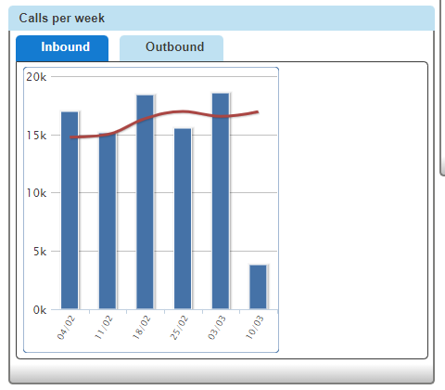
Graph 1 shows the amount of calls received by the Practice within the last month.
GRAPH 2
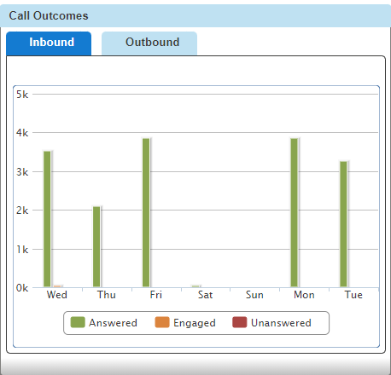
Graph 2 shows the amount of calls received by the Practice within the current week.
Mondays and Fridays are busiest days

